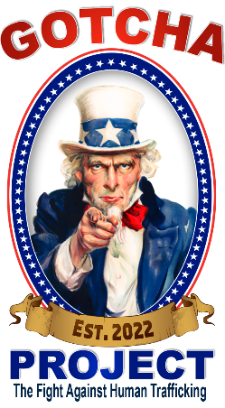

**CONTACT INFORMATION:**

**GOTCHA PROJECT**

**Contact: Dave Graybill**

**Cell: 602-380-8714**

**Dave@Gotchaproject.com**

**FOR IMMEDIATE RELEASE**

**The GOTCHA PROJECT 2023 PRESENTS:**

**World’s Longest Charity Poker Run on Motorcycle**

**To Benefit Charities Focusing on**

**Eliminating the Source Human Trafficking**

**Together We Can Stop It**

[City, State] – [Company/Individual] presents GOTCHA PROJECT 2023, taking place at [Location of Event] on [Date].

The GOTCHA PROJECT, brought to you by Dave Graybill, is proud to bring The World’s Longest Charity Poker Run to Stop Human Trafficking to **[Dealership/Location of Event]**. This 4700-mile event will kick off in Clearwater, Florida on September 10th at the OCC Road House & Museum and Bert’s Barracuda Harley Davidson and finish on October 22nd at Chandler Custom Cycles in Chandler, Arizona. Our travel team consists of a variety of motorcyclists and thematically wrapped vehicles. All proceeds to benefit charities who work to eliminate Human Trafficking. For example, Operation Underground Railroad, a charitable organization that uses technology and counterterrorism methodologies to stop human trafficking at its source, the trafficker.

**WIN A 2023 ROADGLIDE!!**



Purchase raffle tickets via QR Code, online at GOTCHAPROJECT.COM or day of event, make a general donation, or become a sponsor. The day’s event will feature [dealership adds items for their location such as performers, guests, showcases, etc.]. Proceeds to benefit Operation Underground Railroad and other similar charities who are dedicated to:

* Disrupting the human trafficking network.
* Driving human traffickers out of business.
* Identifying the human traffickers for prosecution.
* Rescuing current victims and preventing future ones.

**JOIN THE RIDE!!**

Show your support doing what you love! Contact us if you or your group would like to join the ride. We are meeting bikers all along the way who will be escorting us in and out of town, from event to event. We would love to have you show your support for this once in a lifetime event!

**DEALERSHIP PARTICIPATION**

Dave Graybill is not only the founder of GOTCHA PROJECT but also the founder of one of the country’s largest, all volunteer non-profits, Pink Heals. He has been supported for the past 16 years by biker organizations as Pink Heals National toured the country, bringing his iconic pink firetrucks and philanthropic program to cities and towns nationwide. Harley Davidson has often hosted events and showed support for Pink Heals “Keep it Local” mantra. We know each dealership is unique and the ability to host and promote this event will vary widely. Not expected, but very much appreciated would be any of the following shows of support:

* Promote our stop by inviting your network to come out and meet the team, see the vehicles, and buy a raffle ticket to win the Sound of Freedom 2023 Harley Davidson Road Glide.
* Create a poker run prior to our arrival to donate to the fundraiser.
* Contact your local clubs or your local HOG chapter and ride with us to our next stop.
* Add something to the bike, making it a custom bike when the event is done.
* Promote the event and provide music and/or food to engage public participation.

For More Information Contact:

Dave Graybill, Founder

Phone: 602-380-8714

Email: Dave@Gotchaproject.com

Raffle Tickets provided upon request:

